**Part:3 Find the culprits and nail them-debugging javascript.**

**1. Fix the code to get the largest of three.**

**let aa = (f,s,t) => {**

**if(f>s &&f>t){**

**console.log(f)}**

**else if(s>f && s>t){**

**console.log(s)}**

**else{**

**console.log(t)}**

**}**

**aa(1,2,3);**

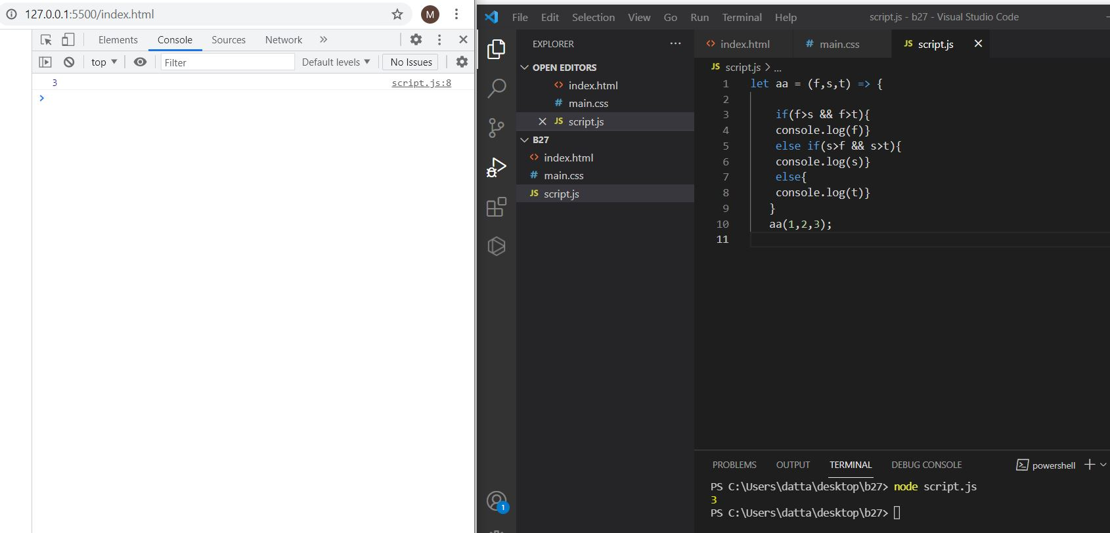

**2. Fix the code to Sum of the digits present in the number**

**let n = 123;**

**console.log(add(n));**

**function add(n)**

**{**

**let sum ;**

**for(sum = 0; n > 0;**

**sum += n % 10,**

**n = parseInt(n / 10));**

**return sum;**

**}**

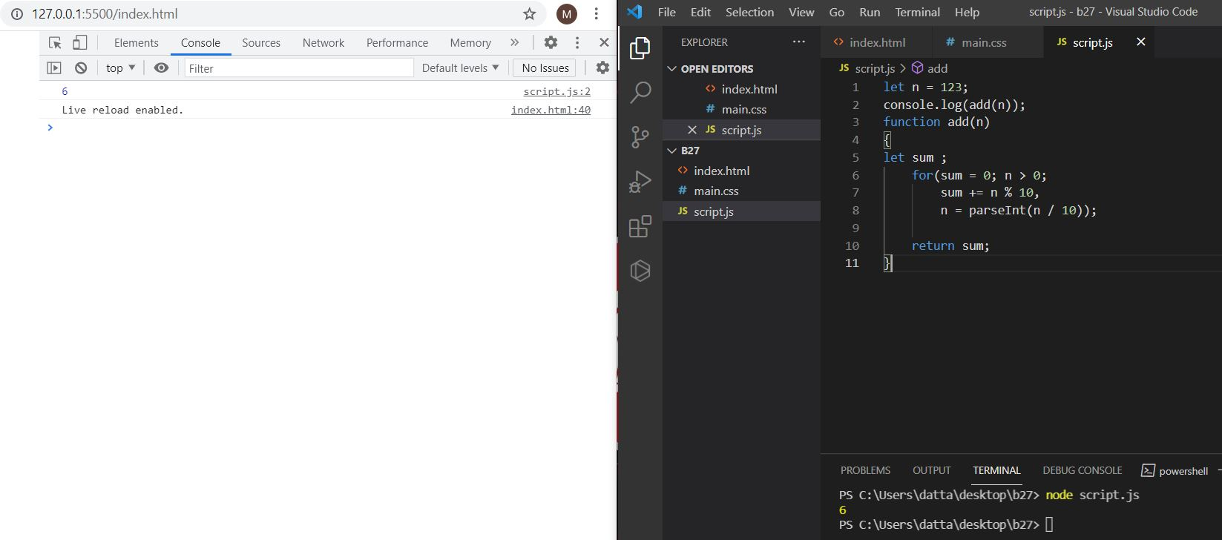

**3. Fix the code to Sum of all numbers using IIFE function**

**const arr = [9,8,5,6,4,3,2,1];**

**(function() {**

**let sum = 0;**

**for (var i = 0; i < arr.length; i++){**

**sum += arr[i];**

**}**

**console.log(sum);**

**return sum;**

**})();**

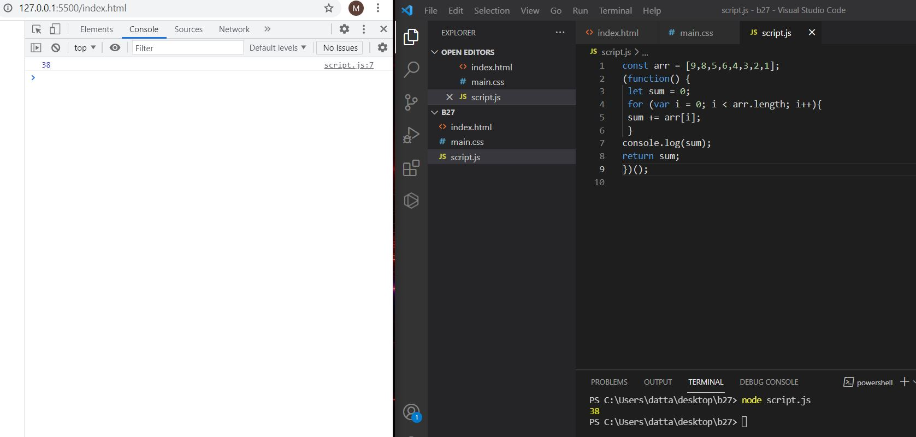

**4. Fix the code to gen Title case.**

**# All first letters in title case.**

**var arr = ["guvi", "geek", "zen", "fullstack"];**

**var ano = function() {**

**for (var i = 0; i < arr.length; i++) {**

**console.log(arr[i][0].toUpperCase() + arr[i].substr(1));**

**}**

**};**

**ano();**

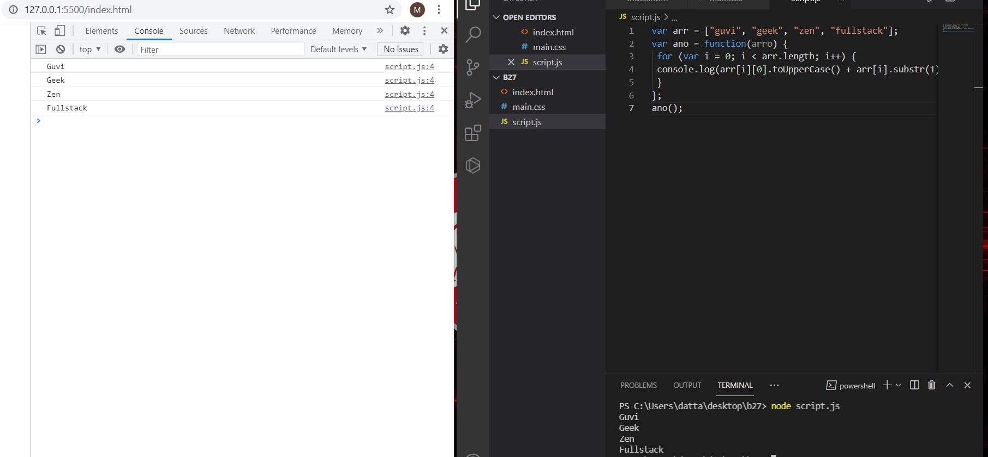**5. Fix the code to return the Prime numbers**

**const newArray=[1,3,2,5,10];**

**const myPrime=newArray.filter(num=>{**

**for(let i=2;i<=Math.sqrt(num);i++){**

**if(num%i===0)**

**{**

**return false;**

**}**

**else{**

**return true**

**}**

**}**

**return num!==1;**

**});**

**console.log(myPrime);**

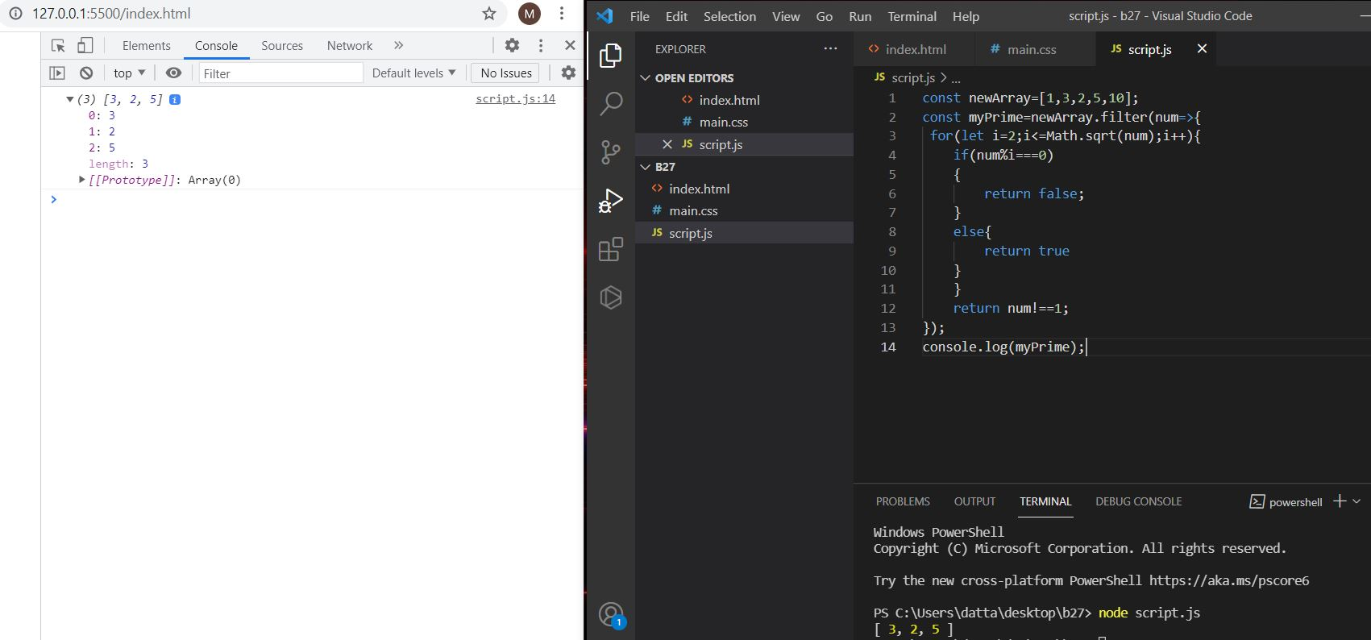

**6. Fix the code to sum the number in that array**

**const num = [10, 20, 30, 40,50,60,70,80,90,100]**

**const sum = (a, b) =>**

**a + b**

**const newsum = num.reduce(sum)**

**console.log(newsum);**

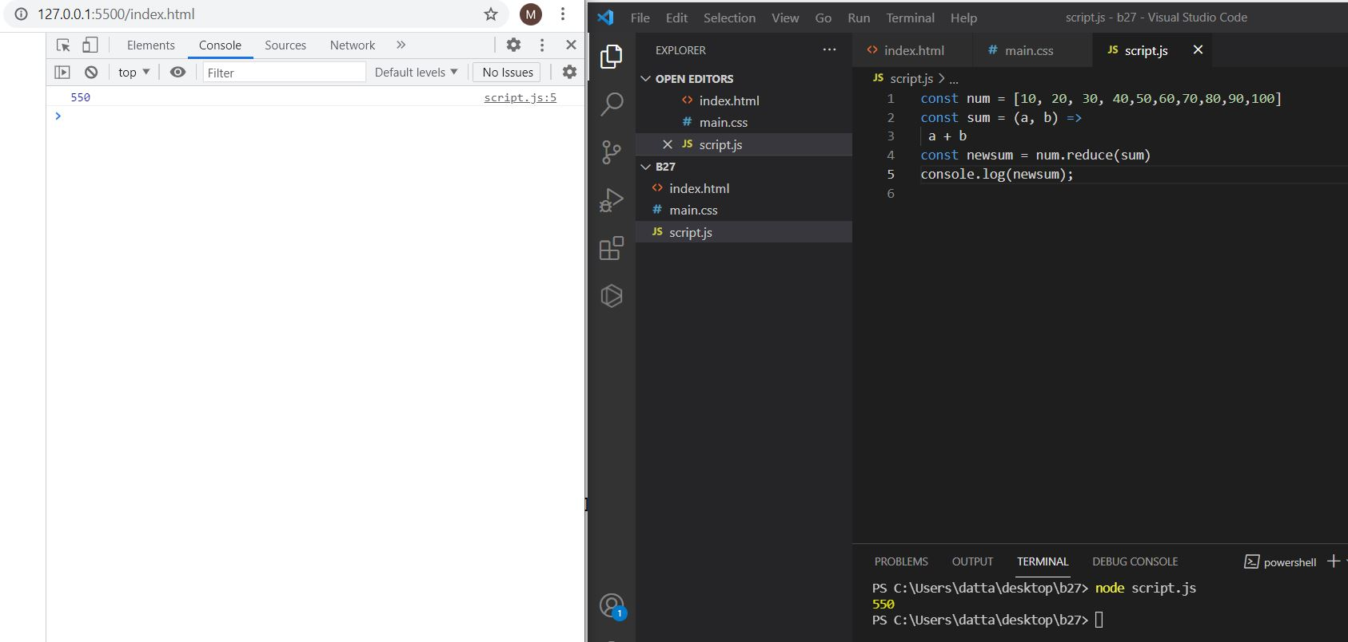

**7. Fix the code to rotate an array by k times and return rotated array using IIFE function**

**var arr = [1, 2, 3, 6, 8, 6, 1, 9, 10, 12, 13];**

**var k = 3;**

**k = arr.length % k;**

**(function(out) {**

**for (var i = 0; i < k + 1; i++) {**

**arr.unshift(arr.pop());**

**}**

**console.log(out);**

**})(arr);**

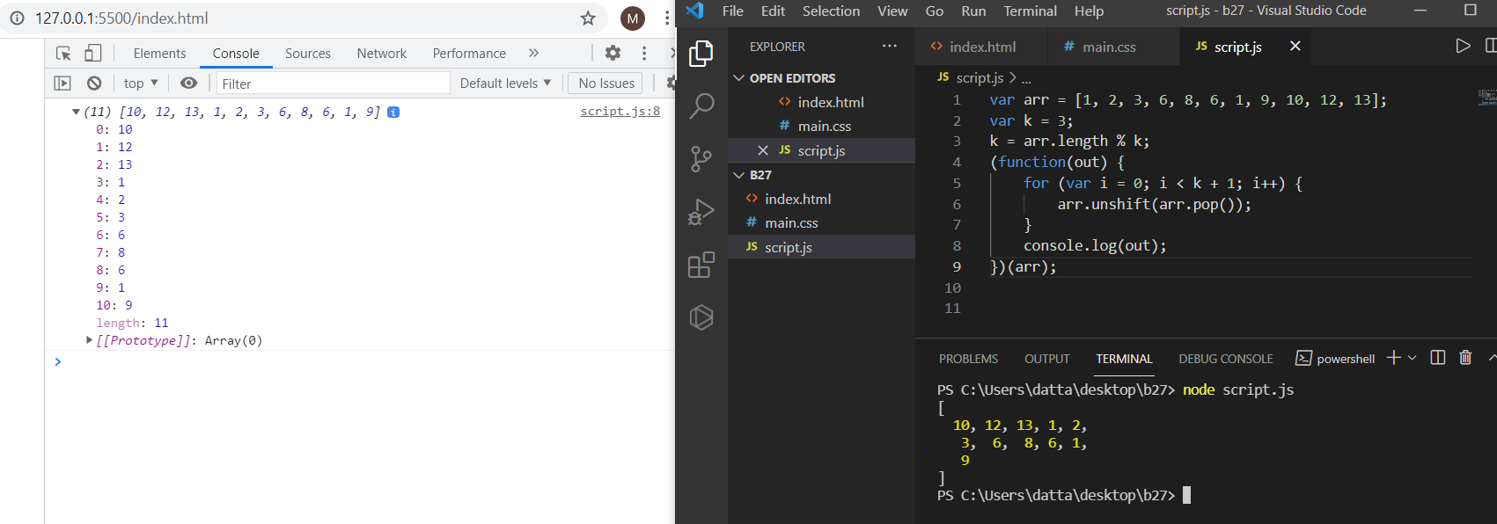

**8. Fix the code to gen Title case.**

**# All first letters in Title case**

**var arr = ["guvi", "geek", "zen", "fullstack"];**

**(function() {**

**for (var i = 0; i < arr.length; i++) {**

**console.log(arr[i][0].toUpperCase()+arr[i].substr(1));**

**}**

**})();**

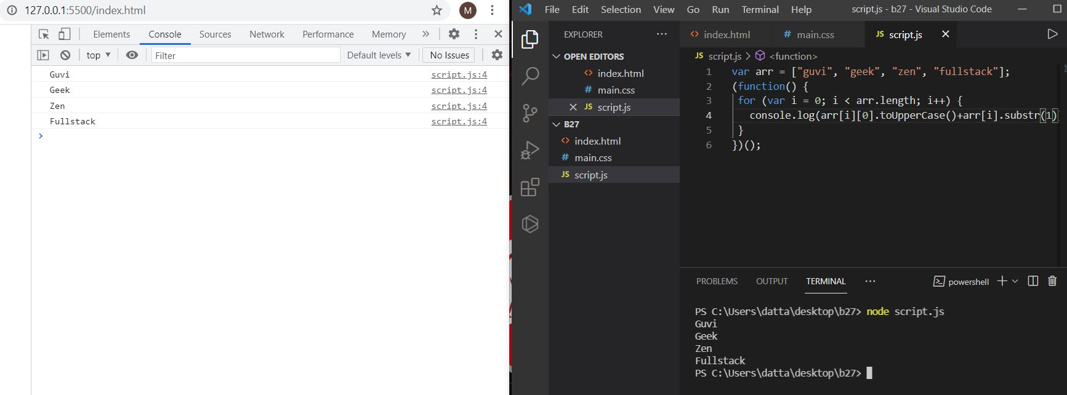

**9. print all odd numbers in an array using IIFE function**

**var arr = [1, 2, 3, 5, 7, 79, 7, 2, 6, 9, 4];**

**(function() {**

**for (var i = 0; i < arr.length; i++) {**

**if (arr[i] % 2 !== 0) {**

**console.log(arr[i]);**

**}}**

**})();**

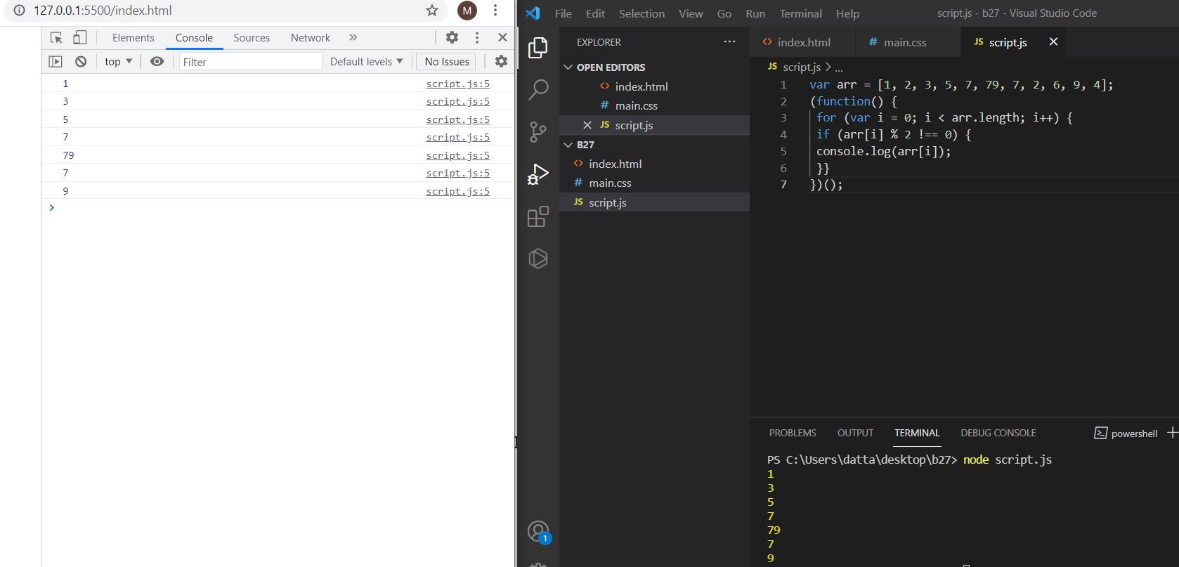

**10. Fix the code to reverse.**

**(function(str){**

**var letters = [];**

**letters = str.match(/\S+/g);**

**var str1 = "";**

**for (var i = 0; i < letters.length; i++) {**

**str1 += letters[i].split('').reverse().join('') + " ";**

**}**

**console.log(str1);**

**})("abcd");**

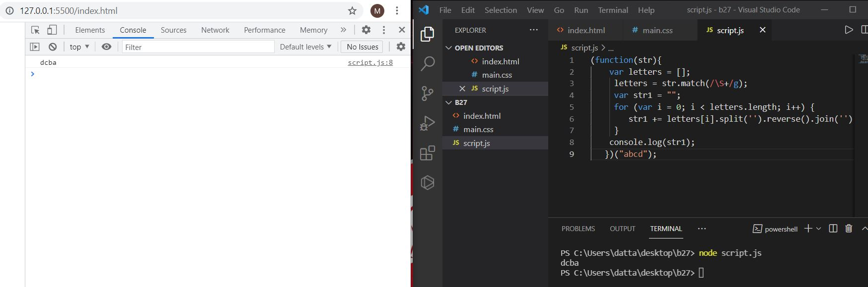

**11. Fix the code to remove duplicates.**

**var res = function(arr){**

**var newArr = [];**

**for(var i=0; i < arr.length; i++){**

**if(newArr.indexOf(arr[i]) === -1) {**

**newArr.push(arr[i]);**

**}**

**}**

**console.log(newArr);**

**};**

**res(["guvi","geek","guvi","duplicate","geeK"]);**

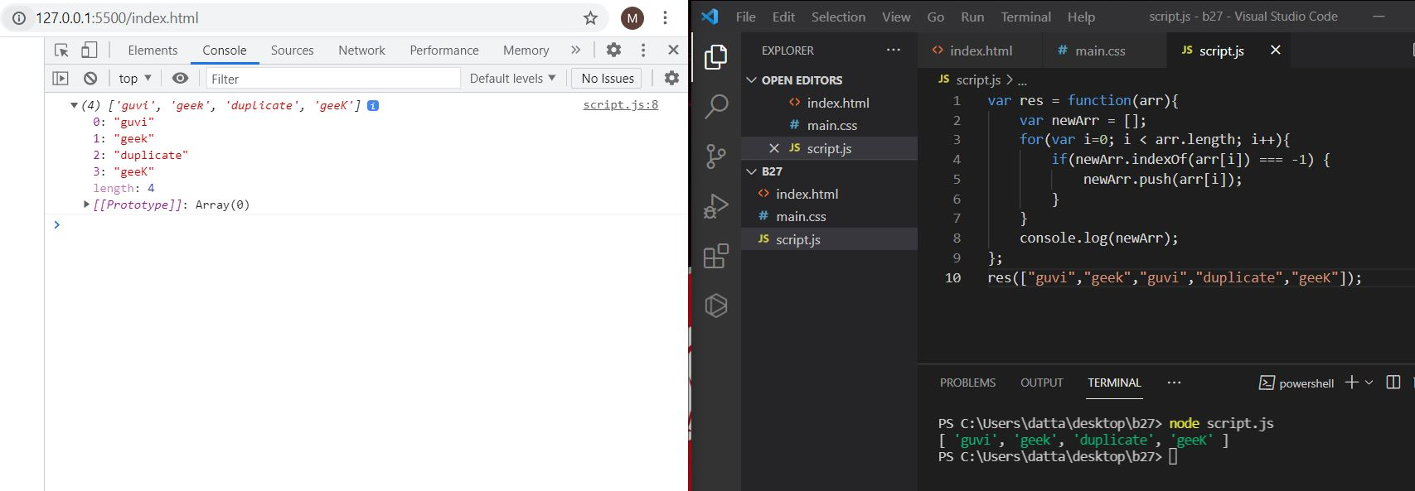

**12. Fix the code to give the below output:**

**Expected Output:**

**[**

**{firstName: “Vasanth”, lastName: “Raja”, age: 24, role: “JSWizard”},**

**{firstName: “Sri”, lastName: “Devi”, age: 28, role: “Coder”}**

**]**

**var array =[[["firstname","vasanth"],["lastname","Raje"],["age",24],["role","JSWizard"]],[["firstname","Sri"],["lastname","Devi"],["age",28],["role", "Coder"]]];**

**var final=[];**

**while(array.length!==0)**

**{**

**var outer_remove = array.shift();**

**var new_object = {};**

**while(outer_remove.length!==0)**

**{**

**var inner_remove = outer_remove.shift();**

**var key = inner_remove[0];**

**var value =inner_remove[1];**

**new_object[key]=value;**

**}**

**final.push(new_object);**

**}**

**console.log(final);**

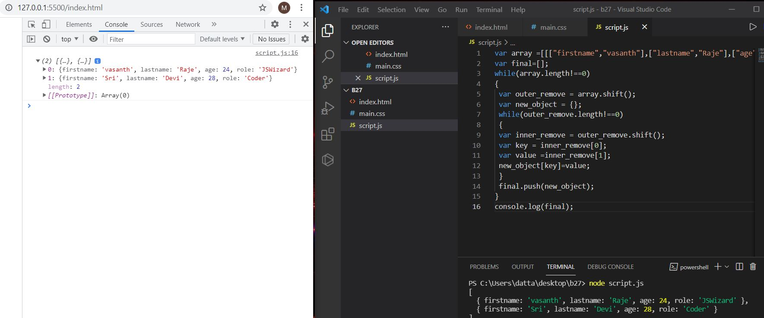

**13. Fix the code to give the below output**

**Sum of odd numbers in an array**

**let as=[12,34,5,6,2,56,6,2,1];**

**let s=as.reduce(function(a,c,i){**

**if (i === 1){**

**if(a%2!==0){**

**if(c%2!==0){**

**return a+c;**

**} return a;**

**}return 0;**

**}else if (c%2!==0){**

**return a+c;**

**}return a;**

**});**

**console.log(s);**

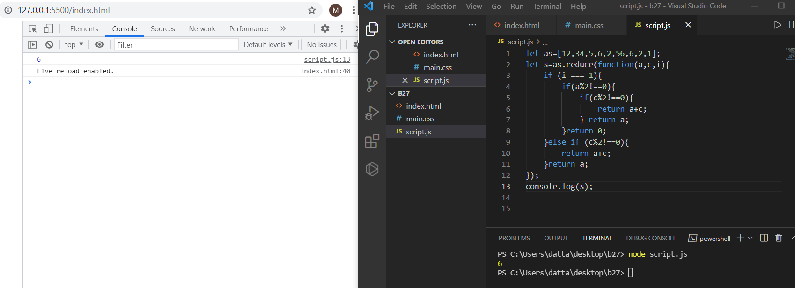

**14. Fix the code to give the below**

**output:**

**Swap the odd and even digits**

**let aa = data=>{**

**var a=data;**

**var l='';**

**for(let i=0;i<a.length-1;i++){**

**//var l='';**

**var s=a[i+1];**

**var b=a[i];**

**l+=s;**

**l+=b;**

**i=i+1;**

**}**

**if((a.length%2)!==0){**

**l+=a[a.length-1];**

**}**

**console.log(l);**

**};**

**aa("1234");**

